SYSTEMS DIVISION

IPD SAS CLASS
TEST PLAN DOCUMENT
WR # 2111

DRAFT

Prepared By:
Back Office IPD Team

1. SAS CLASS File creation test 4
1.1. SAS CLASS file creation test 4
1.1.1. Test Description: 4
1.1.2. Test Environment 4
1.1.3. Expected Results 4
1.1.4. Actual Results 4

SAS CLASS FILE CREATION Test

SAS Class File Creation Test

Test Description:
The SAS Class file to be reconciled resides on the MVS system. It should be copied to DASD for the verification. The DSN is BACKUP.TM.CLASS(0) or whatever generation is appropriate. The tester will need an MVS logon to do this.
The following script will be used to create the SAS Class extract file: createSasClassFile. The series file FTPd to MVS is TS333ID.BACKUP.TM.CLASS

Test Environment
IPD and ipdsd000 and MVS.

Expected Results
- Compare is TS333ID.BACKUP.TM.CLASS with is BACKUP.TM.CLASS(0) or whatever generation is appropriate. The data content should be identical.

Actual Results
The data in the MVS files.
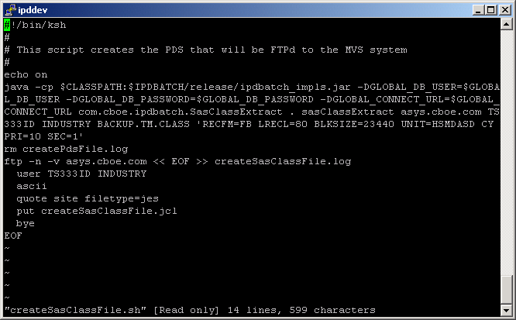
This is the unix script createSasClassFile.sh. The default next trading day is obtained from the This script will create the unix file sasClassExtract that will be FTPd to MVS with the name TS333ID.BACKUP.TM.CLASS.

